ASSIGNMENT – 6
Responsible ai

Name : A.Bhavitha
Roll no. : 2603A52L02

Task Description #1 (Privacy & Security in File Handling) :

Task: Use an AI tool to generate a Python script that stores user data (name, email, password) in a file.

Prompt :

Code:
import hashlib
import json
import secrets
from pathlib import Path
from getpass import getpass

DATA_FILE = Path("users.json")

def hash_password(password, salt=None):
salt = salt or secrets.token_hex(16)
password_hash = hashlib.pbkdf2_hmac(
"sha256",
password.encode(),
salt.encode(),
100_000,
).hex()
return salt, password_hash

def save_user():
name = input("Name: ")
email = input("Email: ")
password = getpass("Password: ")

salt, password_hash = hash_password(password)

users = []
if DATA_FILE.exists():
users = json.loads(DATA_FILE.read_text())

users.append({
"name": name,
"email": email,
"password_hash": password_hash,
"salt": salt,
})

DATA_FILE.write_text(json.dumps(users, indent=4))
print("User data saved successfully.")

if __name__ == "__main__":
save_user()

output :

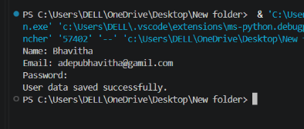

Task Description #2 – Fair Decision Logic

Task: Prompt an AI tool to generate a scholarship eligibility checker based on academic score,
family income, and location. Examine whether the logic unfairly favors or disadvantages any
group.

Prompt: Generate a Python scholarship eligibility checker using academic score, annual family income, and location. Use transparent, explainable rules. Then identify whether any rule could unfairly favor or disadvantage a group, especially through location-based requirements.

Code :

ELIGIBLE_LOCATIONS = {"rural", "urban", "town"}
MIN_SCORE = 75
MAX_INCOME = 500000

def check_eligibility(score, family_income, location):
location = location.strip().lower()

reasons = []

if score < MIN_SCORE:
reasons.append("Academic score is below the minimum requirement.")

if family_income > MAX_INCOME:
reasons.append("Family income is above the maximum requirement.")

if location not in ELIGIBLE_LOCATIONS:
reasons.append("Location is not covered by this scholarship.")

return len(reasons) == 0, reasons

score = float(input("Academic score: "))
income = float(input("Annual family income: "))
location = input("Location category (rural, urban, or town): ")

eligible, reasons = check_eligibility(score, income, location)

if eligible:
print("Eligible for the scholarship.")
else:
print("Not eligible.")
for reason in reasons:
print("-", reason)

output :

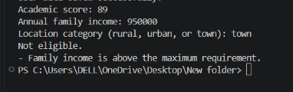

Task Description #3 (Transparency in AI-Based Admission System)

Prompt :
Generate a transparent Python admission eligibility checker using entrance exam score, academic marks, and relevant non-sensitive criteria. Do not use protected characteristics. Explain each decision and identify possible fairness concerns.

Code :
MIN_ENTRANCE_SCORE = 70
MIN_ACADEMIC_MARKS = 60
MIN_INTERVIEW_SCORE = 50

def assess_applicant(entrance_score, academic_marks, interview_score):
reasons = []

if entrance_score < MIN_ENTRANCE_SCORE:
reasons.append("Entrance exam score is below the minimum.")

if academic_marks < MIN_ACADEMIC_MARKS:
reasons.append("Academic marks are below the minimum.")

if interview_score < MIN_INTERVIEW_SCORE:
reasons.append("Interview score is below the minimum.")

selected = not reasons
return selected, reasons

def main():
entrance_score = float(input("Entrance exam score (0-100): "))
academic_marks = float(input("Academic marks (0-100): "))
interview_score = float(input("Interview score (0-100): "))

selected, reasons = assess_applicant(
entrance_score, academic_marks, interview_score
)

if selected:
print("Recommendation: Select for admission.")
else:
print("Recommendation: Reject or review manually.")
for reason in reasons:
print("-", reason)

if __name__ == "__main__":
main()
output :
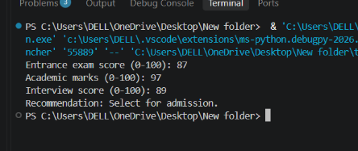
Task Description #4 – Ethical Scoring System

Prompt :
Generate a transparent Python employee performance evaluation system using project completion rate, teamwork score, and attendance. Explain the weights, provide reasons for the result, and analyze possible bias or unethical scoring.

Code:
def evaluate_employee(completion_rate, teamwork_score, attendance_rate):
# Weights prioritize work results while including collaboration and reliability.
score = (
completion_rate * 0.50
+ teamwork_score * 0.30
+ attendance_rate * 0.20
)

if score >= 85:
rating = "Excellent"
elif score >= 70:
rating = "Satisfactory"
else:
rating = "Needs Improvement"

return round(score, 2), rating

completion = float(input("Project completion rate (0-100): "))
teamwork = float(input("Teamwork score (0-100): "))
attendance = float(input("Attendance rate (0-100): "))

if not all(0 <= value <= 100 for value in (completion, teamwork, attendance)):
print("All values must be between 0 and 100.")
else:
score, rating = evaluate_employee(completion, teamwork, attendance)
print(f"Overall score: {score}/100")
print(f"Performance rating: {rating}")

output :
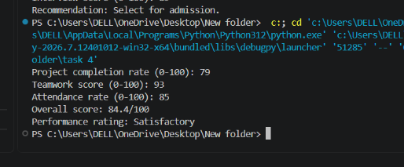

Task Description #5 – Accessibility and Inclusiveness

Prompt :
Generate an accessible Python user feedback form. Use inclusive language, optional demographic fields, clear validation, and allow users to skip questions. Review the form for bias and accessibility concerns.

code :
import json
from datetime import datetime
from pathlib import Path

FEEDBACK_FILE = Path("feedback.json")

def ask(prompt, required=False):
while True:
value = input(prompt).strip()
if value or not required:
return value
print("This response is required. You may type 'prefer not to say' where available.")

def collect_feedback():
print("User Feedback Form")
print("You may skip any optional question.\n")

feedback = {
"submitted_at": datetime.now().isoformat(timespec="seconds"),
"name": ask("Name (optional): "),
"email": ask("Email (optional): "),
"rating": ask("Overall rating from 1 to 5 (optional): "),
"comments": ask("What could we improve? (optional): "),
"accessibility_needs": ask(
"Accessibility needs or accommodations (optional): "
),
"preferred_contact": ask(
"Preferred contact method: email, phone, none, or prefer not to say: "
),
}

return feedback

def save_feedback(feedback):
records = []

if FEEDBACK_FILE.exists():
try:
records = json.loads(FEEDBACK_FILE.read_text(encoding="utf-8"))
except json.JSONDecodeError:
print("Existing feedback file is invalid. Creating a new file.")

records.append(feedback)
FEEDBACK_FILE.write_text(
json.dumps(records, indent=4),
encoding="utf-8",
)

if __name__ == "__main__":
save_feedback(collect_feedback())
print("\nThank you. Your feedback was saved.")

output :
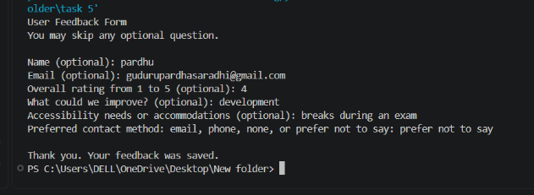

Task Description #6 (Fairness in Loan Approval System)

Prompt :
Generate a transparent, educational Python loan-screening program using income, age, employment status, credit score, and loan amount. Provide reasons for each result, avoid protected characteristics, and explain potential bias. Do not present the result as a final lending decision.

Code:
MIN_CREDIT_SCORE = 650
MIN_AGE = 18
MIN_MONTHLY_INCOME = 25000
MAX_LOAN_TO_ANNUAL_INCOME = 5

def screen_application(age, monthly_income, employment_status,
credit_score, loan_amount):
reasons = []
annual_income = monthly_income * 12

if age < MIN_AGE:
reasons.append("Applicant must be at least 18 years old.")

if monthly_income < MIN_MONTHLY_INCOME:
reasons.append("Income is below the stated minimum.")

if employment_status.lower() not in {"employed", "self-employed"}:
reasons.append("Employment status does not meet the stated requirement.")

if credit_score < MIN_CREDIT_SCORE:
reasons.append("Credit score is below the stated minimum.")

if loan_amount > annual_income * MAX_LOAN_TO_ANNUAL_INCOME:
reasons.append("Requested loan amount is high relative to annual income.")

return not reasons, reasons

age = int(input("Age: "))
income = float(input("Monthly income: "))
employment = input("Employment status: ")
credit = int(input("Credit score: "))
loan = float(input("Requested loan amount: "))

approved, reasons = screen_application(age, income, employment, credit, loan)

if approved:
print("Preliminary result: Meets stated criteria.")
else:
print("Preliminary result: Does not meet stated criteria.")
for reason in reasons:
print("-", reason)

print("This is not a final lending decision. Human and regulatory review is required.")

output :

